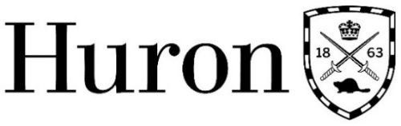

Huron University College Research Ethics Board
Annual Project Review or Termination Report

(Revised May 2018; January 2019)

REB #
REB Approval Date
REB Expiry Date

Project Title
Principal Investigator(s)
Department
Email Address

SECTION 2: Participants
For this project to date, how many participants:
- Were contacted?
- Agreed to participate?
- Participated, but did not complete the study?
Have there been any adverse incidents that have not already been reported to the REB?

SECTION 3: Status of Research
Please indicate the current status of the project as either IN PROGRESS or COMPLETE.
If in progress, answer questions 1-3. If complete, answer 4-6.

In Progress
- I confirm that there is no new information that may affect the HUC REB’s continuing approval of the project. Any future revisions will be reported to the HUC REB for re-approval.

- How many more participants will be contacted before completion of the study?

- Has the study been extended? If so, please provide details.

Research Complete
- I confirm that all contact with participants is complete and so this project will not require any further HUC REB guidance or approval.

- Indicate total number of participants involved in study.
- Please outline briefly plans for publication or dissemination of data.

SECTION 4: Signature
By typing your name you agree that the information in this form is accurate:

Name of Principal Investigator
Date

According to Article 6.14 of the TCPS 2 (2014): “At minimum, continuing ethics review shall consist of an annual status report (for multi-year research projects), and an end-of-study report (projects lasting less than one year).”

