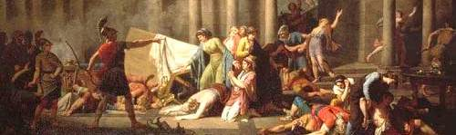

Global Great Books: The Pursuit of Happiness

Professor: Dr. John P. Hope
Email: jhope24@huron.uwo.ca
Office: A211
Office Hours: TBD
Prerequisites: None

Course Description
What is happiness? How do we define it? How can we attain it? Is happiness a reliable indicator of a life well lived, or is it a mirage drawing us away from a higher purpose? In this course we will trace the paths of heroes and sages, philosophers and mystics as they chase after happiness and strive to determine what constitutes a good life. From Odysseus’s homecoming to Siddhartha’s home-leaving, from Aristotle’s embrace of reason to Raskolnikov’s flashes of inspiration, we will watch our guides wrestle with some of the most compelling questions of human existence, and we will make their pursuit our own.

Learning Objectives
This course aims to help students to:
- Explore ideas about the human condition and articulate their own
- Understand the historical and cultural contexts of ideas
- Analyze and articulate their own belief systems
- Improve their ability to understand and engage with philosophical arguments
- Increase their skills literary analysis
- Gain familiarity with works from a variety of global traditions
- Hone their ability to write clearly and argue convincingly

Course Method
Class will unfold primarily as discussion, with occasional forays into lecture when necessary. Students are expected to come to class having done the reading and identified questions and areas of interest.

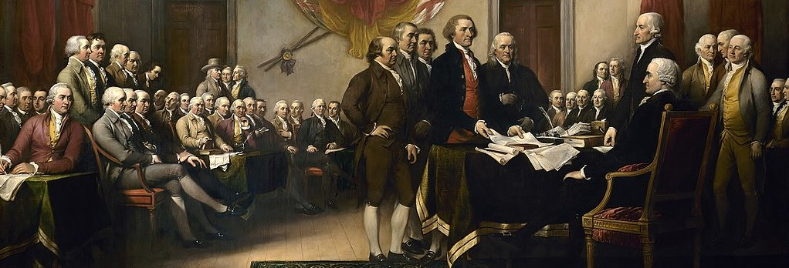

Required Resources
- Homer, The Odyssey (trans. Richard Lattimore)
- Aristotle, The Nicomachean Ethics
- Lao Tzu, The Tao Te Ching (trans. Stephen Mitchell)
- The Life of Milarepa
- Herman Hesse, Siddhartha
- Fyodor Dostoevsky, Crime and Punishment (trans. Pevear and Volokhonsky)
All other readings will be provided on our OWL website.

Assessment
Grades will be determined by the following assignments:
- Preparation and participation: 30%
- Paper #1: 20%
- Paper #2: 20%
- Midterm exam: 15%
- Final exam: 15%

Discussion board
Included in your class participation grade is the requirement to contribute eight paragraph-length postings to our OWL discussion board (owl.uwo.ca). These may take the form of a comment on the reading, a question, or an idea you want to try out. Basically, this is a way to continue our discussion outside of the classroom, and to give everyone an opportunity to express their ideas. To receive full credit, you should make your post before 11 a.m. on the day of class, and your post should concern the reading or topic of the upcoming discussion.

Writing Assignments
Over the course of the semester you will write two 5-page papers analyzing the works we will read and discuss. These papers will be graded on the viability of your thesis, the coherence of your argument, your use of textual evidence to support your points, and your attention to language, style, and structure. Topics and further guidelines will be presented as the deadlines approach.

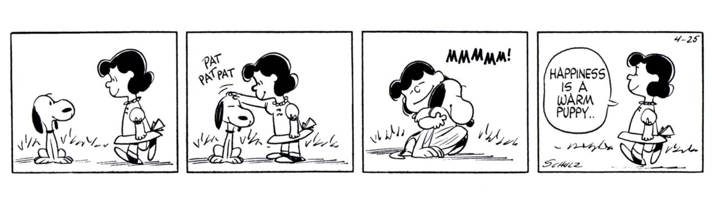

Exams
There will be a midterm exam in class and an exam during finals period. You will have two hours for each. The date and time of the final exam will be announced by the university. Please do not make any travel plans until you know when the exam will take place. No alternate arrangements will be made.

COURSE POLICIES:

Attendance
At its core, this course is meant to be a conversation, and this conversation can only happen if you are there to participate. For your sake and the sake of your companions in the pursuit of happiness, attendance is mandatory. After three unexcused absences, each additional absence will result in your final grade being lowered by 10%. If you have a compelling reason to miss class I ask you to let me know. If you are unsure as to whether your reason is compelling, please discuss it with me.

Technology in the Classroom
All phones must be powered down and put away. I also prefer that laptops not be used in class, though you may discuss this with me if you have a need or a strong preference to take notes in this way.

Missed or Late Work
Late assignments will not be accepted, and as a rule I do not grant extensions the night before an assignment is due. However, some flexibility is possible. Look over the syllabus and check it against your schedule. If you have a conflict I am willing to work with you to set a new deadline, provided that you contact me well in advance. For more information on academic accommodations for medical and non-medical reasons please consult the appendix below.

SAMPLE COURSE SCHEDULE

Thu. 9/5 Course introduction

Tue. 9/10 Homer, The Odyssey
Thu. 9/12 The Odyssey

Tue. 9/17 The Odyssey
Thu. 9/19 The Odyssey

Tue. 9/24 The Odyssey
Thu. 9/26 Aristotle, The Nicomachean Ethics

Tue. 10/1 Ethics
Wed. 10/2 Paper #1 Due
Thu. 10/3 Ethics

Tue. 10/8 Ethics
Thu. 10/10 Lao Tzu, The Tao Te Ching

Tue. 10/15 Reading Week
Thu. 10/17 Reading Week

Tue. 10/22 Midterm Exam
Thu. 10/24 The Pali Canon (selections)

Tue. 10/29 The Life of Milarepa
Thu. 10/31 The Life of Milarepa

Tue. 11/5 Herman Hesse, Siddhartha
Thu. 11/7 Thomas Jefferson, The Declaration of Independence

Tue. 11/12 Fyodor Dostoevsky, Crime and Punishment
Wed. 11/13 Paper #2 due
Thu. 11/14 Crime and Punishment

Tue. 11/19 Crime and Punishment
Thu. 11/21 Crime and Punishment

Tue. 11/26 Crime and Punishment
Thu. 11/28 Crime and Punishment

Tue. 12/3 Leo Tolstoy, The Death of Ivan Ilych
Thu. 12/5 Course Conclusion

