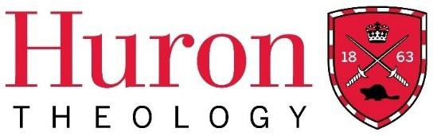
Transfer Credit Requirements Policy: Licentiate in Theology Diploma Program

Transfer Credit
Students applying to transfer into the Licentiate in Theology Diploma Program may request the program Director to present a petition to the Dean of Theology for a student to transfer up to eight courses for pre-degree (Licentiate or Certificate level) work done at other Association of Theological Schools accredited institutions or other institutions approved by the Huron Faculty of Theology. Approval of transfer credits into Huron’s LTh program is at discretion of the Dean of the Faculty of Theology only.

No transfer credit will be granted for any grade less than a “B”, or a mark of 70%.
A maximum of eight transfer credits would amount to the completion of 50% of the courses required to complete the LTh diploma (16 credits total).

LTh Students Considering Huron’s MDiv and MTS Programs
Students who have completed courses Huron’s Licentiate in Theology program may petition for transfer of LTh courses to the MDiv or MTS programs at a rate of 3 LTh courses per 0.5 MDiv or MTS elective courses up to 2.0 courses for the MDiv and 1.5 courses for the MTS. Further application of these transfer elective courses to program requirements is at the discretion of the Dean of the Faculty of Theology. No transfer credit will be granted for any LTh grade less than a “B-,” and only LTh courses taken for a letter grade may be transferred.
The final evaluation of a student's competency and correspondence of courses rests with the Dean of the Faculty of Theology. The Dean will notify the student either directly or through the agency of the Licentiate in Theology Program Director of the outcome of the student’s petition within 12 weeks of the date of the student’s petition.

This policy was approved by Huron University College’s Faculty of Theology Committee in December of 2022.

