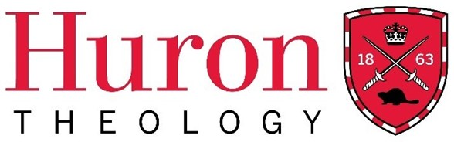

Winter Term 2024
Worship 350: Presiding for the People of God
With Bishop William Cliff
A Course in The Licentiate in Theology Diploma Program

Huron University College Land Acknowledgment

Huron is situated on the traditional lands of the Anishinaabeg, Haudenosaunee, Attawandaron, and Lenape peoples, whose sharing and stewardship of the land has been governed by the Dish with One Spoon treaty since time immemorial. We are guided by this treaty in the spirit of peace, friendship, and respect. Huron University College acknowledges its past role in perpetuating colonial and exclusionary relations. Because religious and ecclesial institutions were instrumental in such relations, we consider it our particular responsibility as a Faculty of Theology to work towards justice and reconciliation.

Course Dates: March 14th, 21st; April 4th, 18th, and 25th; May 2nd.
Please note: there are no classes on March 28th and April 11th.
Time: Thursdays from 7 – 9 P.M. (CT), 8 – 10 P.M. (ET)
Delivery: Hosted via Zoom
Instructor: The Right Reverend William G. Cliff, MA, DD
Contact: bishop@ontario.anglican.ca Phone: (613) 544-4671

Course Description
This course will examine aspects of the practice and theories behind presiding at liturgies for the people of God. Understanding posture, ritual language, liturgical authority in the church, and the different situations in which we are called to preside: sacraments, offices, prayer services and Ecumenical events. Particular attention will be paid to ways in which presiders may need to adapt or transform best practices in response the needs of communities.

This course is primarily PRACTICAL and meant to help those who are already presiding and working in churches in communities of all sizes and parts of the church.
Course Objectives and Learning Outcomes
At the end of this course, students will have an introductory knowledge of the practice and theory of presiding. They will be able to understand proper adaptation of liturgical practice in light of cultural adaptation in a sensitive and thoughtful way. It will also give a framework for the local Canadian experience (which varies widely) in the Book of Common Prayer and the Book of alternative Services.

Required Texts

The Principal Texts/Documents for this course will be The Book of Common Prayer (1962) and the Book of Alternative Services (1985) and other articles will be distributed as appropriate from other sources as “Strong Loving and Wise” by Robert W. Hovda, Readiness and Decency by Roland F. Palmer and John W. Hawes, and chapters of other books as distributed.

Course Outline/Plan

Week 1 Having a body – worshipping as a body

- Posture, gesture, the place of ritual, “universal gestures” and why this whole Body thing is important for presiders. Nerves, tension, and what to do about them in yourself and in others.

Week 2 Ritual Language

- The words we use for one another, “common prayer” , the words we use for God – the words we use to speak to God. Many books in use and their meaning.

Week 3 Prayer – How we pray together – why we pray together

- Biddings, petition, intercessions, forms, language, silence, versicles and responses, chanted prayer, and all the other forms of public prayer you can think of… and whose job is every one of these forms!

Week 4 Offices

- Daily prayer – theory and practice of Morning and Evening Offices in BAS and BCP. Other Offices – Midday prayers. Prayers in religious communities, canticles and how to use them.

Week 5 Sacraments

- Care and set up, management and support of the sacramental life. Baptisms, Weddings, Anointings, Confirmation, Confession and Holy Eucharist (ordination if we have time for it)

Week 6 The Book of Common Prayer and the Book of Alternative Services
Liturgical Authority and Authorization

- The principles and pitfalls of each book. Understanding what the editors were trying to do. Understanding the recent history of liturgical revisions and the revolution that desktop publishing and other technology has had on our worship. - Copyright, “I found this online”, principles of authorization around the Communion and throughout Canada. What authority do I have in my parish, and when do I check with the bishop?

Method of Evaluation and Criteria for Grading (only for students choosing to be evaluated for full course credit)

Two document studies (500 words each) and a Final Essay (1000 words) will be completed by each student seeking evaluation for full LTh credit.
1. Class Engagement/Participation – 20%
2. Document Study – 20% An Office and its liturgical options and pitfalls
3. Document Study – 20% A Sacrament and its liturgical options and pitfalls
4. Final Essay – 40% How I understand the practice of presiding for the people of God.

A full description and evaluative expectations document will accompany each the document studies and the final essay.

Huron Grade Descriptors
A+ | 90-100 | One could scarcely expect better from a student at this level
A | 80-89 | Superior work which is clearly above average
B | 70-79 | Good work, meeting all requirements, and eminently satisfactory
C | 60-69 | Competent work, meeting requirements
D | 50-59 | Fair work, minimally acceptable
F | below 50 | Fail

Student Code of Conduct
Membership in the community of Huron University College and Western University implies acceptance by every student of the principle of respect for the rights, responsibilities, dignity and well-being of others and a readiness to support an environment conducive to the intellectual and personal growth of all who study, work, and live within it. Upon registration, students assume the responsibilities that such registration entails.
While in the physical or online classroom, students are expected to behave in a manner that supports the learning environment of others. Please review the Student Code of Conduct at: https://huronatwestern.ca/sites/default/files/Res%20Life/Student%20Code%20of%20Conduct%20-%20Revised%20September%202019.pdf.

Statement on the Recording of Class Activities
Students may not record or distribute any class activity, including conversations during office hours, without written permission from the instructor, except as necessary as part of approved accommodations for students with disabilities. Any approved recordings may only be used for the student’s own private use.

Online courses within the Licentiate in Theology Program are recorded for student engagement purposes. These recording are only used by the registered students of the class and made available through a restricted video hosting site to respect both privacy and intellectual property. Should a student be uncomfortable with this practice, they can contact the course instructor or the LTh Program Director, Dr. Grayhame Bowcott at grayhame.bowcott@huron.uwo.ca

Support Services
For advice on course selections, degree requirements, and for assistance with requests for medical accommodation, students should contact the LTh Program Director, Dr. Grayhame Bowcott at grayhame.bowcott@huron.uwo.ca.

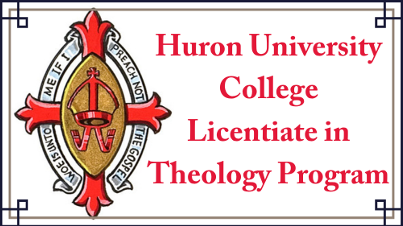

THIS COURSE HAS BEEN [NOT YET BEEN] APPROVED BY HURON’S FACULTY OF THEOLOGY COMMITTEE
FOR THE WINTER TERM OF THE LTH PROGRAM, 2024.

